Geography Skills Study Guide Name:_______________

Part 1: Continents and Oceans
- Name the 7 Continents:
- Name the 5 oceans:
- Label them on the map (1-12)
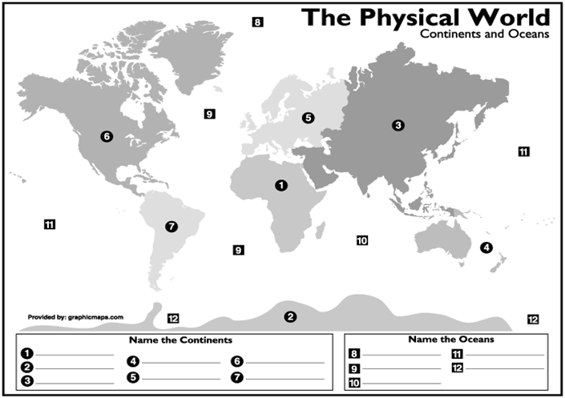

Part 2 : Latitude and Longitude
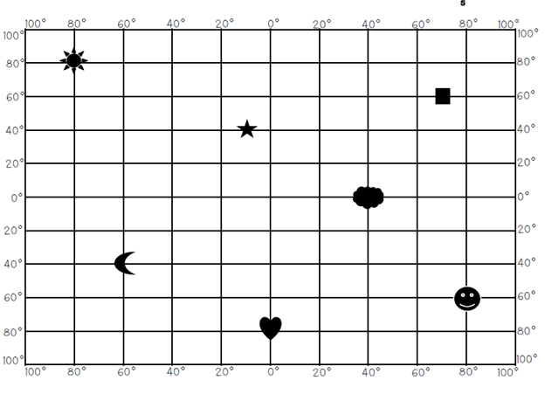
- Draw a DOT on the coordinates 80N, 30E
- Draw a TRIANGLE on the coordinates 20S, 40W
- Draw a DIAMOND on the coordinates 0, 70E
- What are the coordinates of the heart?
- What are the coordinates of the star?

Part 3: Reading a Map
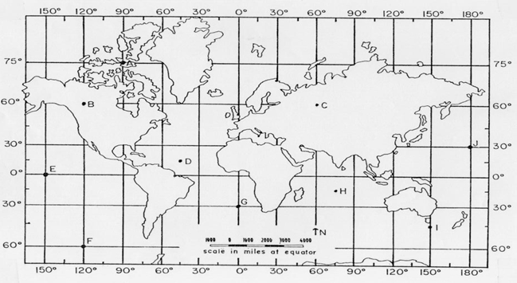
- Name the Latitude and Longitude of the following points...
A= ______________ B=_________________ C=__________________D=______________________
2. Color the equator Blue
3. Color the Prime Meridian red
4. Circle the map scale

Part 4: Enduring Understandings
For each enduring understanding, write a description in your own words, give an examples, and a draw a picture or symbol to represent it.

Enduring Understanding | Description | Example | Picture/ Symbol
Production, Distribution, and Consumption
Movement and Migration
Human Environmental Interaction
Culture
Conflict and Change
Location
Time, Change, and Continuity
Governance

